**Tutorial 12 & 13**

**Trees**

1. Given a binary tree of size 76, what is the minimum number of levels it can contain? What is the maximum number of levels?

[**NOTE**: Size of a binary tree is the number of nodes in the tree.]

To determine the minimum number of levels to contain a specific number of nodes, we need to consider the maximum number of nodes at each level since the nodes will have to be organized with each level at full capacity.

From the above diagram we can conclude that the minimum number of levels of a binary tree of size n is [log2n] + 1 E.g

* If size of tree is 7, minimum number of levels is [log27] + 1 = 2 + 1 = 3
* If size of tree is 8, minimum number of levels is [log28] + 1 = 3 + 1 = 4

Therefore, for a binary tree of size 76, the minimum number of levels is

[log276]+1 = 6 + 1 = 7 **levels**

The maximum number of levels is 76 levels (when there is one node per level)

2. What is the maximum number of nodes possible in a binary tree with 5 levels?

**Solution:**From the above diagram, we can conclude that maximum number of nodes possible in a binary tree occurs when it is a perfect binary tree( a full binary tree in which all the leaf nodes are at the same level.  
  
For a binary tree with n levels, the maximum number of nodes is 2^^n – 1 E.g

* If number of levels is 3, the maximum number of nodes is 2^^3 – 1 = 7
* If number of levels id 4, the maximum number of nodes is 2^^4 – 1 = 15

Therefore, the **maximum number of nodes** of a binary tree with 5 **levels** is:

* 2^^5 – 1 = 32 Nodes

1. Given the following binary trees:   
     
   Chart

   Description automatically generated

1. a. Indicate all the structure properties that apply to each tree: **full**, **perfect** and **complete**.
2. b. Determine the **size** of each tree.

[**NOTE**: Size of a binary tree is the number of nodes in the tree.]

1. c. Determine the **height** of each tree.

[**NOTE**: Height of a binary tree is the maximum **depth** of any node in the tree.]

1. d. Determine the **width** of each tree.

[**NOTE**: Width of a binary tree is the number of nodes on the level containing the most nodes.]

**Lecturer Solution**

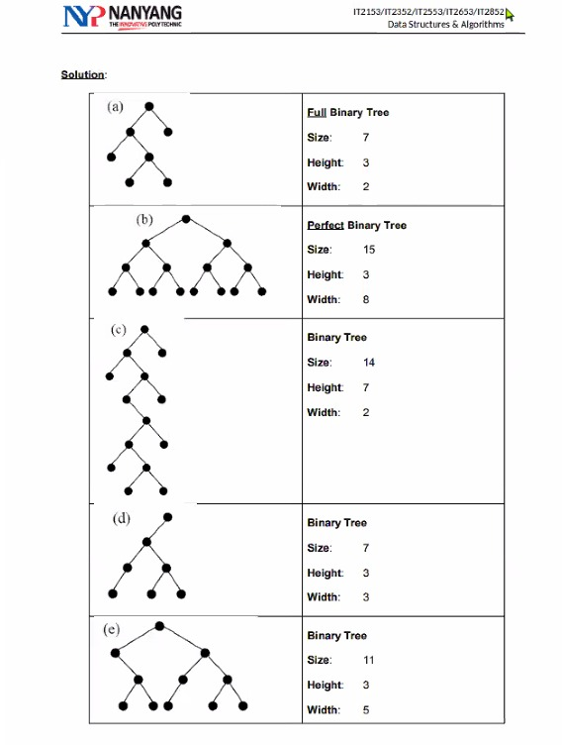

Drawing Versions:  
  
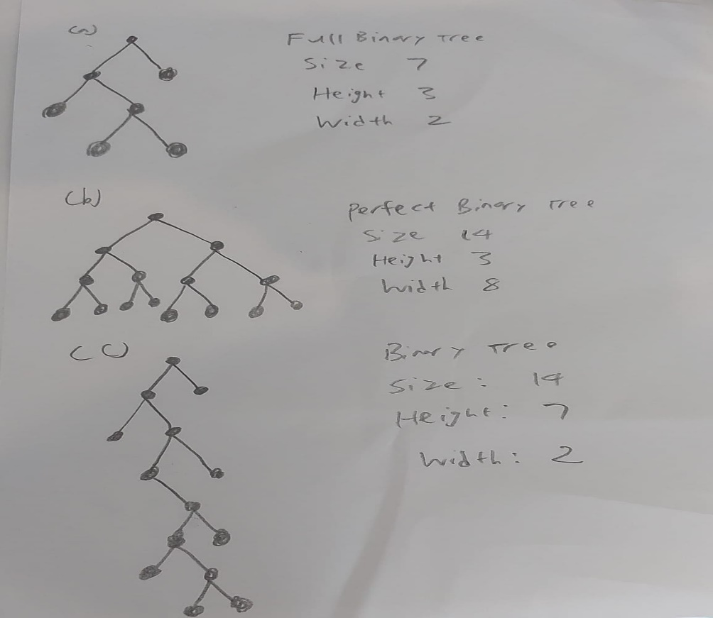  
  
  
  
4. Consider the following binary tree:   
  
*(Content from Reference Text: Data Structures & Algorithms using Python. Rance D. Necaise, Wiley, 1st Edition, 2011)*

1. a. Show the order that the nodes will be visited in the following tree traversal methods:

(i) Pre-order traversal

**14 78 39 52 83 17 8 41 2 60 23 4 19**

(ii) In-order traversal

**39 78 17 83 9 52 41 14 60 2 4 23 19**

(iii) Post-order traversal   
  
**39 17 9 83 41 52 78 60 4 19 23 2 14**

(iv) Breadth-first traversal   
  
 **14 78 2 39 52 60 23 83 41 4 19 17 9**

1. b. Identify all of the leaf nodes.   
     
    **39 17 9 41 60 4 19**
2. c. Identify all of the interior nodes. ‘

**14 78 52 83 2 23**

1. d. List all of the nodes on level 4.   
     
     **17 9**
2. e. List all of the nodes in the path to each of the following nodes:
   * + 1. (i) 83   
            
           **14 78 52 83**
3. (ii) 39

**14 78 39**

1. (iii) 4

**14 2 23 4**

1. (iv) 9

**14 78 52 83 9**

1. f. Consider node 52 and list the node’s:
2. (i) descendants

**83 17 9 41**

1. (ii) ancestors
3. **14 78**
4. (iii) siblings   
     
    **39**
5. g. Identify the depth of each of the following nodes:
6. (i) 78 Depth **= 1**
7. (ii) 41 Depth = 3
8. (iii) 60 Depth = 2
9. (iv) 19 Depth = 3

5. A binary search tree is created when the numbers are inserted in the following order:

30, 63, 2, 89, 16, 24, 19, 52, 27, 9, 4, 45

Draw the binary search tree.

**Lecturer Solution**

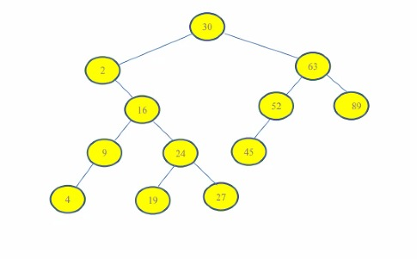  
**Drawing Version:  
  
